- Original intensity image
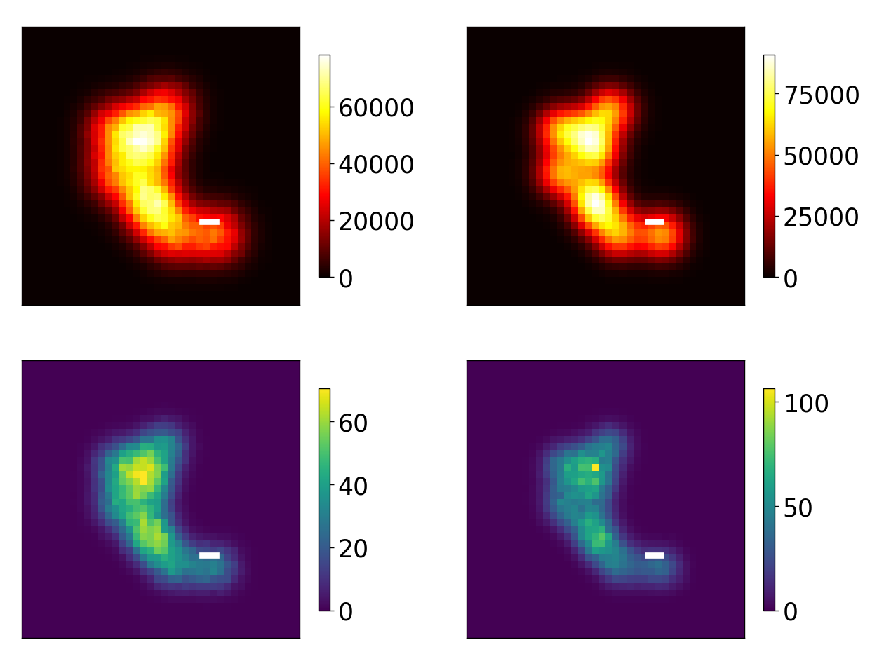
- G2 image

- Intensity ISM image

- G2 Q-ISM image


- Emitter map
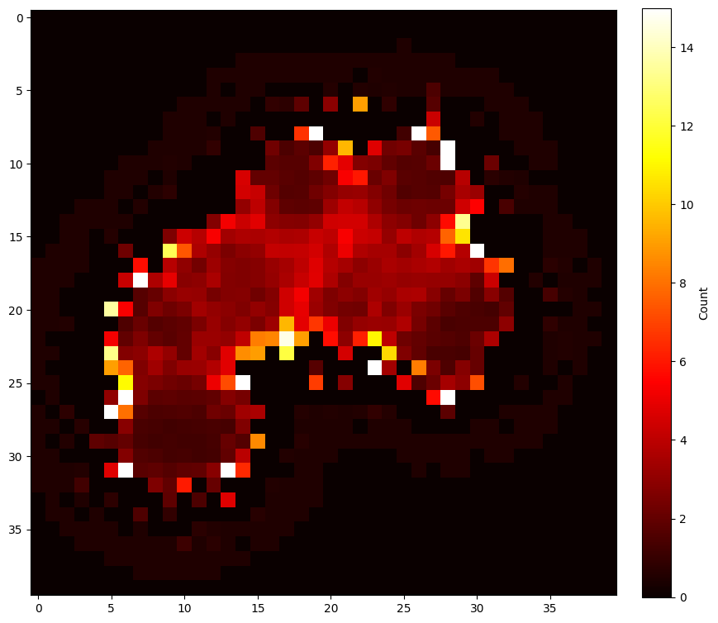
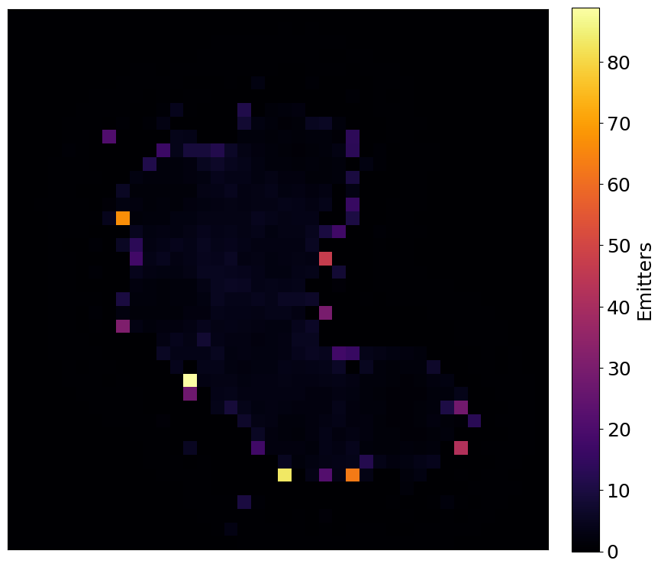
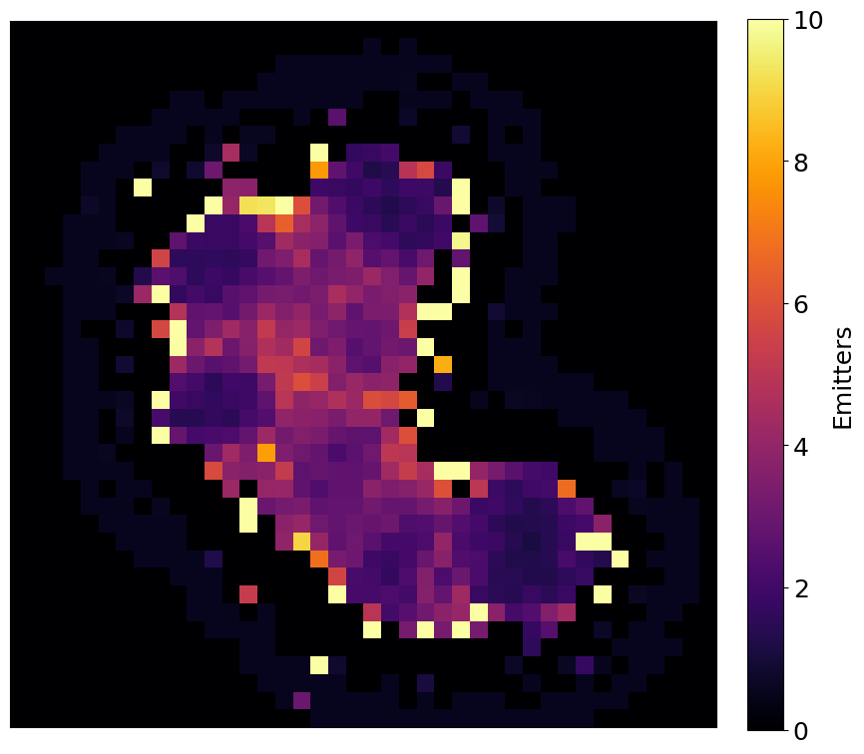
- Deconvolved G2 map
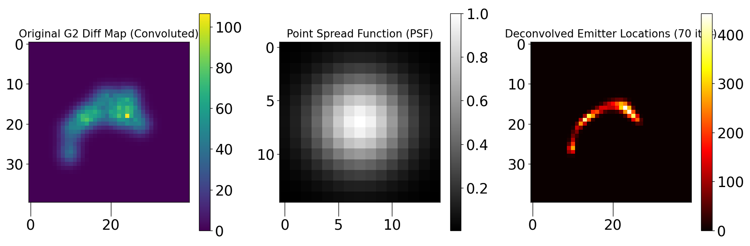
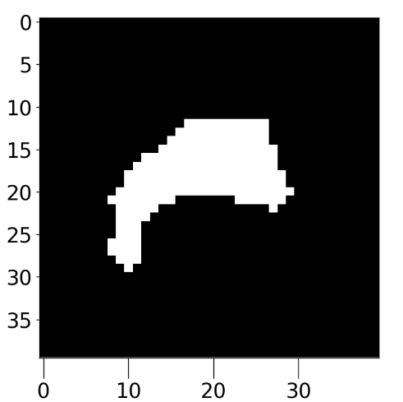
- ROI’s

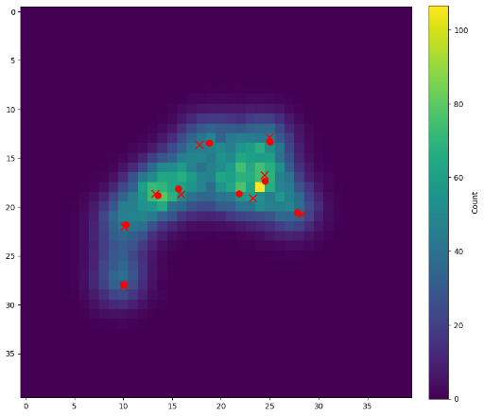
- G2 Q-ISM Map with estimated and ground truth positions (ground truth: circles; crosses: localized positions). In both black and blue version B-)
